8-Puzzle Problem (A* Search)

Aim
To solve the 8-Puzzle Problem by comparing the given initial state with the goal state and determining the number of misplaced tiles using Python.
Objective
- To understand the concept of the 8-puzzle problem.
- To represent the puzzle using a 3 × 3 matrix.
- To compare the initial state with the goal state.
- To calculate the number of misplaced tiles.
- To display both the initial and goal states.
Algorithm
- Start the program.
- Define the goal state as [1,2,3,4,5,6,7,8,0].
- Read the initial state from the user.
- Compare the initial state with the goal state.
- If both states are equal, display "Goal State Reached".
- Otherwise, count the number of misplaced tiles.
- Display the number of misplaced tiles.
- Print the initial state in 3 × 3 format.
- Print the goal state in 3 × 3 format.
- Stop the program.

Code:
print("=" * 60)
print(" ARTIFICIAL INTELLIGENCE LAB")
print(" Experiment: 8 Puzzle Problem")
print(" Name : Vinnarasu R")
print(" Reg No : 192411040")
print("=" * 60)

goal = [1, 2, 3, 4, 5, 6, 7, 8, 0]

print("Enter the initial state (9 numbers):")
state = list(map(int, input().split()))

if state == goal:
print("\nGoal State Reached!")
count = 0
else:
count = 0
for i in range(9):
if state[i] != goal[i]:
count += 1

print("Misplaced Tiles =", count)

print("\nInitial State:")
for i in range(0, 9, 3):
print(state[i:i+3])

print("\nGoal State:")
for i in range(0, 9, 3):
print(goal[i:i+3])

output:
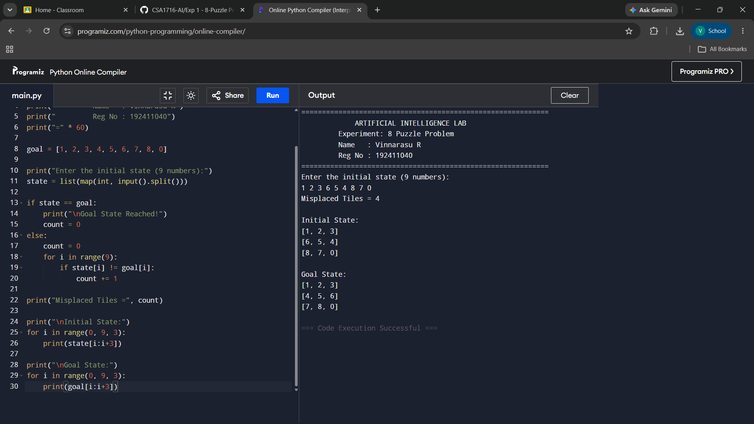
Result:
The 8-Puzzle Problem was implemented successfully in Python. The program accepted the initial puzzle state from the user, compared it with the goal state, calculated the number of misplaced tiles, and displayed both the initial and goal states correctly.

